Individual Expert Selection and Ranking of Scientific Articles Using Document Length
Fadly Akbar Saputra¹*, Taufik Djatna² & Laksana Tri Handoko³
¹Department of Computer Science, Faculty of Mathematics and Natural Science,
Bogor Agricultural University, Kampus IPB Darmaga, Bogor 16680, Indonesia
²Department of Agroindustrial Technology, Faculty of Agricultural Technology, Bogor Agricultural University, Kampus IPB Darmaga, Bogor 16680, Indonesia
³Indonesian Institute of Science, Sasana Widya Sarwono (SWS) Jend. Gatot Subroto Street 10, South Jakarta, Indonesia
*E-mail: fadly_saputra@apps.ipb.ac.id

Abstract. Individual expert selection and ranking is a challenging research topic that has received a lot attention in recent years because of its importance related to referencing experts in particular domains and research fund allocation and management. In this work, scientific articles were used as the most common source for ranking expertise in particular domains. Previous studies only considered title and abstract content using language modeling. This study used the whole content of scientific documents obtained from Aminer citation data. The modified weighted language model (MWLM) is proposed that combines document length and number of citations as prior document probability to improve precision. Also, the author’s dominance in a single document is computed using the Learning-to-Rank (L2R) method. The evaluation results using p@n, MAP, MRR, r-prec, and bpref showed a precision enhancement. MWLM improved the weighted language model (WLM) by p@n (4%), MAP (22.5%), and bpref (1.7%). MWLM also improved the precision of a model that used author dominance by MAP (4.3%), r-prec (8.2%), and bpref (2.1%).
Keywords: document length; individual expert; language model; scientific article; selection and ranking.

Introduction
The word ‘expert’ refers to people who have knowledge and expertise in a particular discipline [1]. Expertise indicates the amount of knowledge and skills an expert has acquired. Researches that determine expertise usually aim to rank the experts themselves. The results of expert ranking can potentially be used as a basis for finding collaborative research partners for research governance in both the academic and the industrial world. Using a language model (LM) with the purpose of expert ranking was first introduced by Balog et al. [2] to determine individual rankings by calculating an individual expertise value derived from the title and the abstract content of scientific articles. In recent advancements, the expert ranking process also covers the ranking of expert groups [3]. The difference between the two approaches lies in the final ranking produced: the first produces an individual expert ranking, while the second provides a group expert ranking.
Knowledge from experts can be categorized into two types, namely implicit and explicit knowledge [4]. Implicit knowledge is difficult to assess because this knowledge is usually not documented. Explicit knowledge is knowledge that is easily assessable, readable, and documented or codified [5]. Because of the above reasons, this research used explicit knowledge for expert ranking. One of the sources of explicit knowledge are the contents of scientific articles, which consists of unpublished documents, preliminary communication, patent specifications, conference literature, research reports and research papers.
Previous individual expert ranking researches utilized only the number of citations of documents as prior document probability [6,7]. Basically, the process of individual expert selection and ranking with documents as data source starts with the document finding process. To the best of our knowledge, no previous studies have been done that combined the number of citations and document length as prior probability in expert ranking. The idea behind using document length as prior probability is that a longer document means deeper coverage and more relevant topics without any known query when compared to a shorter document [8]. Using document length as prior probability in document finding can improve precision [9,10]. If we are able to improve the document finding result using document length, the result of expert ranking can be improved as well.
The whole content of the document was used in this research to show the difference between one document and another because the number of words in the title and abstract of scientific articles are unvaried. Compared to title and abstract, the document length content of scientific articles is more varied; according to Björk, et al. [11], the average length of scientific articles is between 3.000 and 10.000 words. For this reason, using the whole content of the document in individual expert ranking is more challenging than using the title and abstract only.
In order to get better expert ranking results, the Learning-to-Rank method (L2R) was used to determine the value of author dominance in the document [7]. Six features from documents and authors were used, i.e. the number of co-authors in the document, AuthorRank [12], Betweenness Centrality [13], the number of previously published documents, the number of attended venues of an author, and the average citation number of the document. The author dominance value was previously obtained by computing the maximum likelihood estimation (MLE).
Based on previous relevant researches, this study used all the content of the document. A new model called Modified Weighted Language Model (MWLM) is proposed, which is a modification of the Weighted Language Model (WLM). MWLM not only uses the citation number of the document, like previous researches, but also the length of the document. Besides, the feature weights used in the model from [7] and the modified model from [7] are also used in MWLM. The method to compute the weight of the features was adopted from [7]. The two models from these previous studies were compared using five evaluation methods: mean reciprocal rank (MRR), precision at n (p@n), average precision (MAP), r-precision, and bpref [6,14-16].

Research Method
In order to reach the research objectives, four steps were conducted: preprocessing; developing the new model; computing the weight of the features; and evaluating the model. Preprocessing was done to convert the documents into text files and involves tokenizing, removing stop words, and stemming with the Porter Stemming algorithm [17].
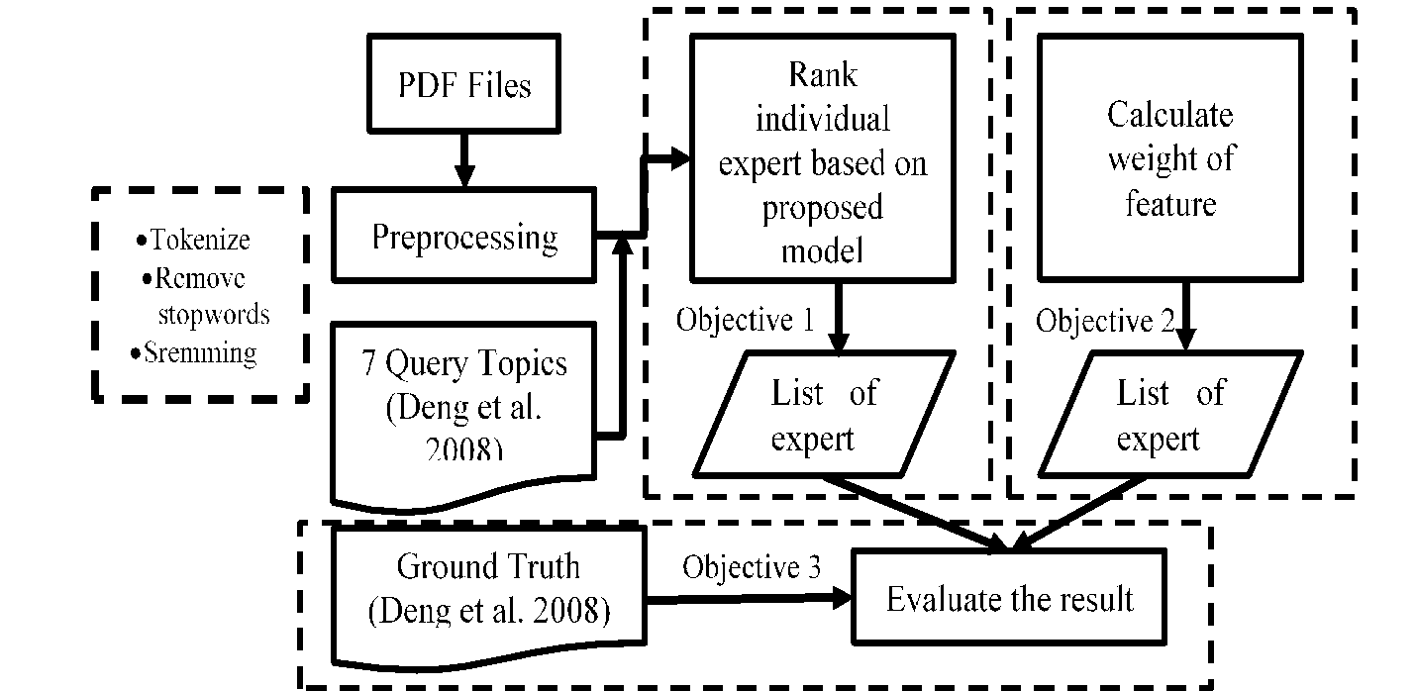
- Research steps.
The second step was to rank the individual experts with WLM and MWLM, followed by comparing the precision of WLM and MWLM based on the average ranking precision for seven query topics. In the next stage, L2R was used to obtain an estimation of the feature weights [7]. Here, the training data used were a collection of documents with at least one ground truth expert as an author. The ground truth was a list of expert names with their respective domain expertises, which had been previously determined manually through a survey. This list was taken from Deng, et al. [6]. The weight of the features was used to get the author dominance value in each document using [7] and using the model from [7] modified with MWLM. The last step was to evaluate the expert list from the four models that were produced. The tools used for this research were Java version 1.8, Python version 3.6, GraphStream version 1.3, psycopg2, PostgreSQL, nltk, PyPDF2, and pyocr. A summary of the research stages as explained above can be seen in Figure 1.
This study modified two models using probabilistic document length as prior document probability from [10] to produce two new models. The new models are called MWLM, which is a modification of WLM, and +MWLM, which is a modification of [7]. Figure 2 shows the proposed model and how the five evaluation methods were used to compare the four models.
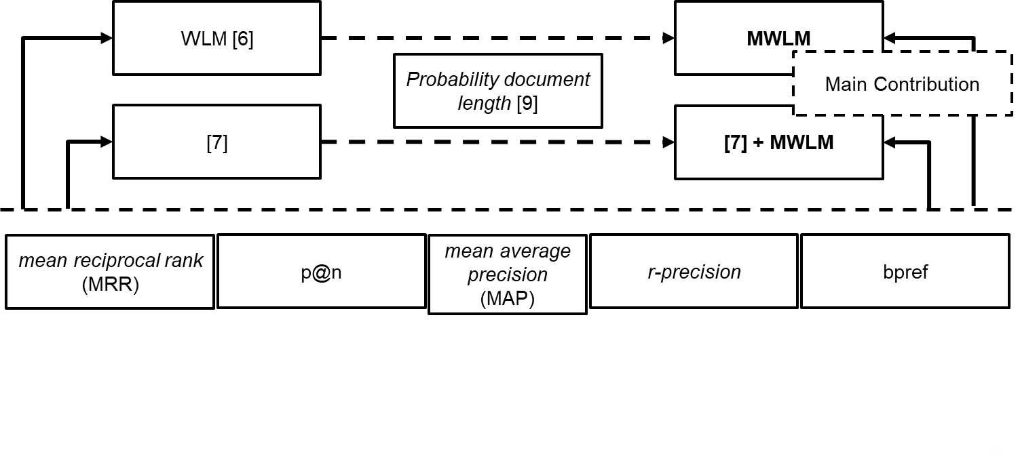
- Modification of previous models and evaluation methods.

Data
The data used in this study was a document that is downloadable from the Aminer citation data set [18]. Seven query topics that have previously been used for expert ranking were taken from [6]. The ground truth used in the evaluation was also obtained from [6]. The number of ground truth experts for each topic can be seen in Table 1.
- Number of ground truth experts.
Query Topic | Number of Experts
Query Topic | [6] | Corpus
Information Extraction | 20 | 14
Intelligent Agents | 29 | 20
Machine Learning | 42 | 20
Natural Language Processing | 43 | 34
Planning | 34 | 12
Semantic Web | 45 | 25
Support Vector Machine | 31 | 11

Improvement Model with Document Length
The previous research reported in [2] assumed the prior document probability to be uniform. Eq. (1) below is the basic equation used in [2]. We adopted the smoothing parameter settings $λ=0.5$ from [7].
$p\left(q\right)=\sum_{d∈D_{ex}}{}p(d)\prod_{t∈q}{}{\left(\left(1-λ\right)p\left(d\right)+λp(t|C)\right)}^{n(t,q)}p(ex|d)$ (1)
where $p(t|d)$ is the number of terms $t$ in document $d$ and $p(t|C)$ is the occurrence of term $t$ in the corpus. Meanwhile, $n(t,q)$ is the number of terms $t$ in query $q$. The value of $p(ex|d)$ shows the association between expert candidate $ex$ and document $d$. Different from [2], the previous research reported in [6] used the number of citations to estimate the prior document probability in addition to the natural logarithmic weight of the number of citations of the document. This approach is called the Weighted Language Model (WLM). The prior probability is estimated with Eq. (2):
$ω_{d}=ln \left(e+c_{d}\right)$ (2)
where $ω_{d}$ is used to replace $p(d)$ in Eq. (1), $e$ is a natural number, and $c_{d}$ is the number of citations of document $d$.
Kraaij et al. [9] used document length as prior probability in document finding and showed that this can increase precision by 0.03. Blanco & Barreiro [10] used the number of terms in the corpus to determine the prior document probability using Eq. (3). Here, the smoothing parameter setting $λ=0.7$ is proposed [10].
$l_{d}=\left(1-λ\right)+λ\sum_{t∈T_{d}}{}p\left(C\right)$ (3)
where $T_{d}$ is the set of terms in document $d$ and $p\left(C\right)$ is the probability of term $t$ in the given corpus.

Features Weight
In this stage, the features are weighted using MLE. In WLM, all authors of a document are considered to have the same level of expertise. In that model, the value of $p\left(d\right)=\frac{1}{N_{ex,d}}$, where $N_{ex,d}$ is the total number of authors in document $d$. This study used the L2R method with a pointwise approach to obtain MLE [7]. MLE is calculated from Eq. (4), after which Eq. (5) is used to estimate $p\left(d\right)$ in Eq. (1):
$θ={argmax}_{θ}\sum_{m=1}^{D_{t}}{}\sum_{ex∈A\left(d_{m}\right)}{}\left({ex}_{t}ln\ln{p_{θ}}\left(c=1|d_{m},ex\right) \right)+(1- {ex}_{t})lnln p_{θ}\left(d_{m},ex\right)$ (4)
$p_{θ}\left(d,ex\right)= \frac{1}{1+e^{\left(-θf_{exm}\right)}}$ (5)
where $θ$ is the maximum log likelihood estimation, $e$ is a natural number, and $f_{exm}$ is the feature vector expert $ex$ in the $m$-th document. Furthermore, ${ex}_{t}$ is a relevant expert on topic $t$ and $p_{θ}\left(c=1|d_{m},ex\right)$ is the relevant expert probability in document $d_{m}$.
The six features obtained from the authors and the document, i.e. the number of co-authors in the venue of the document, AuthorRank [12], Betweenness Centrality [13], the number of previously published documents, the number of attended venues of an author, and the average number of citations of the document. The description of these features is as follows:
- The number of co-authors in the venue of the document represents the collaboration of the authors in one venue. This value is different for each venue for the same author.
- AuthorRank [12] represents the most influential author in the venue. We have to generate a weighted directed graph for each venue first to calculate AuthorRank.
- Betweenness Centrality [13] is used to calculate the most central author among the other authors in each venue.
- The number of previously published documents shows how much the author has published before.
- The number of venues attended by an author represents the experience of an author in publishing. Different from other features, this feature is attached to the author, not the document.
- The average number of citations of the document is calculated from the total number of citations of the document from an author, which represents how many times the document has been used by other studies. The document citation number is available in the Aminer citation data set.

Evaluation
The evaluations used for this expert ranking based on queries are query-level position-based evaluations [15]. The five evaluation methods used in this study were: mean reciprocal rank (MRR), precision at rank n (p@n), mean average precision (MAP), r-precision (r-prec), and bpref [6,14-16].
MRR calculates the first rank of relevant experts based on the ground truth. MRR only looks at the top rank of experts in accordance with the manual assessment. MRR for all queries Q is calculated with Eq. (6) where ${rank}_{i}$ is the rank of the $i$-th ground truth expert.
$MRR= \frac{1}{\left|Q\right|}\sum_{i=1}^{Q}{}\frac{1}{{rank}_{i}}$ (6)
P@n measures the number of relevant experts n in the ranking list. The value of n has several variations, i.e. 10 (p@10), 20 (p@20), and 30 (p@30). The measurement of p@n is calculated by Eq. (7).
$p@n= \frac{\#number of the relevant expert at n results}{n}$ (7)
MAP stands for mean of average precision (AP), which can be calculated from Equation 8, which is calculated for each query $q$:
$AP= \frac{\sum_{n=1}^{N}{}\left(p@n*rel\left(n\right)\right)}{R}$ (8)
where $rel(n)$ is a binary function that indicates how relevant an expert is and $R$ is the number of relevant expert(s) for query $q$.
The next method is called r-precision, which calculates the amount of precision of the expert list, R. The value of R is obtained from the number of relevant experts given by Eq. (9), where $r$ is the number of experts in the top results of $R$.
$r-prec= \frac{r}{R}$ (9)
In addition, the precision was evaluated with the bpref method. Bpref is calculated using Eq. (10).
$bpref= \frac{1}{R}\sum_{{ex}_{r}}{}\left(1-\frac{N_{{ex}_{r}}}{R}\right)$ (10)
where $R$ is the number of the relevant experts in the ground truth, ${ex}_{r}$ is a relevant expert, and $N_{{ex}_{r}}$ is the number of the non-relevant experts.

Results and Analysis
This study used citation data obtained from aminer.cn, with a total of 154,771,162 citations. However, only 248,963 citations contained a downloadable PDF file and there were only 14,892 PDF files that could be converted to text. Hence these 14,892 text files were used as the corpus. Because our data set was reduced compared to the original Aminer citation data, the number of experts in the ground truth was reduced as well. For example, the number of ground truth experts in [6] is 20 experts for the ‘information extraction’ query topic, but there were only 14 experts in that category in our corpus. Table 1 shows the number of experts in our corpus for seven queries.
The citations obtained from aminer.cn are contained in a text file in which each row is a citation in JSON format. The data obtained from each citation contain the following attributes: id, article title, author, venue, year, keyword, page, language, volume, issue, download address, and abstract. This study limited the language of citations to the value ‘en’ for language, which means that the documents were written in English. All of the documents were downloaded in PDF format. The conversion tool pyocr was used to change the PDF format into text and carry out optical character recognition (OCR).

Document Length as a Prior Probability
We propose a new model that combines Eq. (2), which only uses citations from Eq. (2), with the document length from Eq. (3). Hence, $p(d)$ in Eq. (1) is changed to Eq. (11). This new model is called the Modified Weighted Language Model (MWLM). In Eq. (11), the length of the document, $l_{d}$, and the number of citations, $c_{d}$, are used to calculate the natural logarithmic weight of document$ω_{d}$.
$ω_{d}=ln \left(e+(c_{d}* l_{d})\right)$ (11)
where $e$ is a natural number, $l_{d}$ is the length of the document, and $c_{d}$ is the document citation number. $l_{d}$ is estimated with Eq. (3).
As the initial step, WLM was used, assuming that author dominance is on the same level in all documents. Table 2 shows the top ten experts with the highest scores from WLM and MWLM. The bold names are experts from the ground truth. Ground truth experts that occur in this result are ‘Raymond J. Mooney’, ranked first by both models, and ‘Jude W. Shavlik’, ranked tenth by both models. The results in the table show that there was no difference in the number of ground truth occurrences in WLM and MWLM based on the ‘information extraction’ query topic. Basically, the ground truth expert ranking in the results is a benchmark for evaluation. Therefore, the precision of WLM and MWLM in the top 10 result of the ‘information extraction’ query topic is the same. MWLM had a lower score than WLM when comparing every single rank because the value of Eq. (3) is between 0.3 and 1. We applied the smoothing parameter setting$λ=0.7$ in Eq. (3).
- Expert list of query topic ‘information extraction.
WLM |  | MWLM
Name | Score | Name | Score
Raymond J. Mooney | 0.001339668 | Raymond J. Mooney | 0.001065299
Razvan C. Bunescu | 0.001318495 | Razvan C. Bunescu | 0.001046539
Laurent Fribourg | 0.000689425 | Eduard Hovy | 0.000525831
Eduard Hovy | 0.000621864 | Laurent Fribourg | 0.000497475
david buttler | 0.000513553 | david buttler | 0.000418615
ling liu | 0.000513553 | ling liu | 0.000418615
calton pu | 0.000513553 | calton pu | 0.000418615
Hsinchun Chen | 0.000491561 | Hsinchun Chen | 0.000412447
Mary Ellen Okurowski | 0.000419563 | Mary Ellen Okurowski | 0.000380778
Jude W. Shavlik | 0.000363473 | Jude W. Shavlik | 0.000321472
Figure 3 shows the average p@n of WLM compared to the average p@n of MWLM for seven query topics. WLM got a better result than MWLM for the top 12 experts. However, the average precision of MWLM was better than that of WLM for the top 15-30 experts.
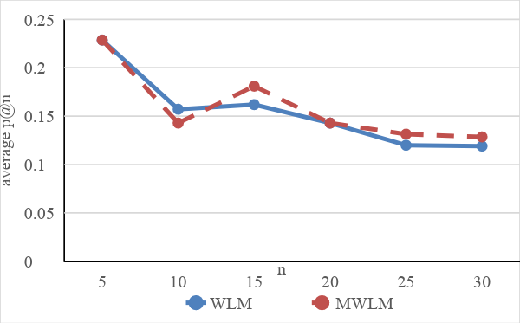
- Average p@n of WLM and MWLM.

Author Dominance Using Feature Weights
The six feature weights obtained using MLE from Eq. (4) sorted by influence are: average author citation number, number of co-authors in the venue of document d, number of attended venues, AuthorRank [12], number of documents published before document d, and Betweeness Centrality [13]. Then, the weight obtained was used to estimate the author dominance value for each document using the logistic function.
The prior documents from Eq. (2) were applied in the model from [7]. Therefore, Eq. (11) could be used to improve the precision of the model in [7]. The results of the expertise ranking using the initial equation in [7] and using the addition of MWLM are shown in Table 3.
Table 3 shows a comparison between [7] and +MWLM [7] for the query topic ‘information extraction’. Based on these results, the ground truth expert ‘Raymond J. Mooney’ ended up in second place in [7], while the same name was at the same rank using +MWLM [7]. Therefore, the precision of the top 10 results of [7] and +MWML [7] for the ‘information extraction’ query topic was the same.
- List of experts using feature weights.
[7] |  | +MWLM [7]
Name | Score | Name | Score
Mary Ellen Okurowski | 0.002846101 | Mary Ellen Okurowski | 0.002610383
Raymond J. Mooney | 0.002040013 | Raymond J. Mooney | 0.00175929
Razvan C. Bunescu | 0.00200853 | Razvan C. Bunescu | 0.001729868
Marek Kowalkiewicz | 0.001826011 | Marek Kowalkiewicz | 0.001696112
Laurent Fribourg | 0.001314774 | Eduard Hovy | 0.001128466
Eduard Hovy | 0.001228973 | Laurent Fribourg | 0.001112363
TIPSTER SE/CM | 0.001124158 | Hsinchun Chen | 0.001020047
Hsinchun Chen | 0.00111446 | TIPSTER SE/CM | 0.000985305
Wang Xun | 0.000962993 | Wang Xun | 0.000887572
Ling Yun | 0.000962993 | Ling Yun | 0.000887572
Figure 4 shows a comparison of the average precision of seven query topics between [7] and +MWLM [7]. Both models had the same precision until the top 15 results. A difference in the results between the two models only occurred from the top 15-30 experts. Figure 4 also shows that the p@n value from +MWLM [7] was better than that of [7] from the top 15-30 results.

- Average P@n of [7] and +MWLM [7].

Evaluation
The results of the expert rankings produced by WLM, MWLM, [7], and +MWLM were evaluated using five evaluation methods, i.e. p@n, MAP, MRR, r-prec, and bpref. The top 30 rank results from all the evaluation methods were used to compare the four models to see the difference in precision, because from the information obtained, as shown in Tables 3 and 4, the models [7] and +MWLM [7] had the same precision values until the top 15 experts. Table 4 shows the results of the evaluation of the four expert ranking models.
- Evaluation results.
Model | p@30 | MAP | MRR | R-Prec | Bpref
MWLM | 0.123809524 | 0.071641291 | 0.54047619 | 0.153869184 | 0.108582
WLM | 0.119047619 | 0.058493768 | 0.547619048 | 0.161572265 | 0.106754
[7] +MWLM | 0.071428571 | 0.04004737 | 0.394444444 | 0.093891375 | 0.06346
[7] | 0.071428571 | 0.038406156 | 0.394444444 | 0.086748518 | 0.062141
According to Table 5, MWLM was the best model according to three evaluation methods. In fact, MWLM performed better than [7] and +MWLM [7] according to all evaluation methods. MWLM succeeded in increasing the precision of WLM using p@30 (4%), MAP (22.5%), and bpref (1.7%). However, MWLM did not perform better than WLM according to MRR and r-prec. The MRR value of WLM was better than MWLM for the ‘intelligent agents’ and ‘natural language processing’ query topics and worse than MWLM for the ‘machine learning’ query topic only. Meanwhile, the r-precision value of WLM was better than that of MWLM for the ‘planning’ query topic.
Meanwhile, the r-precision values of [7] and +MWLM [7] being lower than those of WLM or MWLM shows that the use of feature weights on this corpus did not affect the r-precision values of both models due to insufficient scientific publications used as training data. The percentage of the amount of training data for each query topic was smaller than 1% of all documents in the corpus. However, +MWLM [7] improved the precision of the basic model from [7]. +MWLM [7] improved the precision according to three evaluation methods, i.e. MAP (4.3%), r-prec (8.2%), and bpref (2.1%).
The evaluation results in Table 5 also show that using document length could not improve the previous models according to two evaluation methods, i.e. MRR and r-precision. MRR looks at the ranking of the first ground truth expert appearing on the list. Therefore, according to Figures 3 and 4, the MRR value of MWLM was below that of WLM until the top 12 results and the MRR value of [7] was equal to +MWLM [7]. Based on these results, using document length generally improved the previous models, both WLM and [7], i.e. above the top 12 for WLM and the top 15 for [7].
Based on the discussion above, significant results have provided evidence for Robertson and Walker’s idea [8] of using document length as prior document probability. In the future, collaboration between experts will be compulsory so this research should proceed to include expert group ranking.

Conclusion
Document length was used as prior document probability along with number of citations to rank individual experts. To improve precision, the author dominance value in one document was calculated using six features. The six features, sorted according to influence in our corpus, were: average author citation number, number of co-authors in the venue of the document, the number of attended venues, AuthorRank¸ number of articles published before document d, and Betweenness Centrality. Even though the amount of training data in our corpus was small, these features did not affect the precision of [7] and +MWLM [7].
The evaluation results in p@30, MAP, and bpref present an improvement of MWLM’s precision compared to WLM. Meanwhile, the evaluation results of MAP, r-prec, and bpref showed an improvement of the precision of +MWLM [7] compared to [7]. Based on the results of the evaluation, using document length improved the precision of WLM and [7].
In a future research, document length could potentially also be used for expert group ranking. In addition, the total sum of document length could be used to determine the prior probability of expert groups.
References
- Lin, S., Hong, W., Wang D. & Li T., A Survey on Expert Finding Techniques, J. Intell. Inf. Syst., 49(2), pp. 255-279, 2017.
- Balog, K., Azzopardi, L. & de Rijke, M., Formal Models for Expert Finding in Enterprise Corpora, 29th Annual International ACM SIGIR Conference on Research and Development in Information Retrieval – SIGIR ’06, pp. 43-50, 2006.
- Liang, S. & de Rijke, M., Formal Language Models for Finding Groups of Experts, Information Processing & Management, 52(4), pp. 529-549, 2016.
- Dienes, Z. & Perner, J., A Theory of Implicit and Explicit Knowledge, Behavioral and Brain Sciences, 22(5), pp. 735-808, 1999.
- Hélie, S. & Sun, R., Incubation, Insight, and Creative Problem Solving: A Unified Theory and a Connectionist Model, Psychol. Rev., 117(3), pp. 994-1024, 2010.
- Deng, H., King, I. & Lyu, M.R., Formal Models for Expert Finding on DBLP Bibliography Data, 2008 Eighth IEEE International Conference on Data Mining, pp. 163-172, 2008.
- Neshati, M., Hashemi, S.H. & Beigy, H., Expertise Finding in Bibliographic Network: Topic Dominance Learning Approach, IEEE Trans. Cybern., 44(12), pp. 2646-2657, 2014.
- Robertson, S.E. & Walker, S., Some Simple Effective Approximations to the 2-Poisson Model for Probabilistic Weighted Retrieval, Proceedings of the 17th Annual International ACM SIGIR Conference on Research and Development in Information Retrieval, pp. 232-241, 1994.
- Kraaij, W., Westerveld, T. & Hiemstra, D., The Importance of Prior Probabilities for Entry Page Search, in Proceedings of the 25th Annual International ACM SIGIR Conference on Research and Development in Information Retrieval, pp. 27-34, 2002.
- Blanco, R. & Barreiro, A., Probabilistic Document Length Priors for Language Models, Advances in Information Retrieval, pp. 394-405, 2008.
- Björk, B.C., Roos, A. & Lauri, M., Scientific Journal Publishing: Yearly Volume and Open Access Availability, Inf. Res., 14(1), pp. 394-405, 2009.
- Liu, X., Bollen, J., Nelson, M.L., & Van de Sompel, H., Co-authorship Networks in the Digital Library Research Community, Inf. Process. Manag., 41(6), pp. 1462-1480, 2005.
- Brandes, U., On Variants of Shortest-Path Betweenness Centrality and Their Generic Computation, Social Networks, 30(2), pp. 136-145, May 2008.
- Manning, C.D., Raghavan, P. & Schütze, H., Introduction to Information Retrieval, ed. 1, Cambridge University Press, 2008.
- Liu, T.Y., Learning to Rank for Information Retrieval, Foundations and Trends® in Information Retrieval, 3(3), pp. 225-331, Mar. 2009.
- Balog, K., Fang, Y., de Rijke, M., Serdyukov, P. & Si, L., Expertise Retrieval, Foundations and Trends® in Information Retrieval, 6(2), pp. 127-256, Feb. 2012.
- Porter, M.F., Readings in Information Retrieval, in Jones, K.S. & Willett, P., Eds. San Francisco, CA, USA: Morgan Kaufmann Publishers Inc., 1997, pp. 313-316.
- Tang, J., Zhang, J., Yao, L. & Li, J., Extraction and Mining of an Academic Social Network, Proceeding of the 17th international conference on World Wide Web, pp. 1193-1194, 2008.

https://www.java.com/en/download/ (July, 12 2018)
https://www.python.org/downloads/release/python-365/ (July, 13 2018)
http://graphstream-project.org/ (August, 1 2018)
http://initd.org/psycopg/ (August, 3 2018)
https://www.postgresql.org/ (December, 8 2017)
https://www.nltk.org/ (August, 3 2018)
https://pythonhosted.org/PyPDF2/ (August, 4 2018)
https://github.com/openpaperwork/pyocr (August, 4 2018)
https://github.com/openpaperwork/pyocr

