Supplementary Data

Influence of Room-Temperature Ionic Liquids on the Electrosynthesis of CuBDC Type Metal-Organic Frameworks: Crystallite Size and Productivity

Laela Mukaromah, Yessi Permana, Aep Patah*
Division of Inorganic and Physical Chemistry, Institut Teknologi Bandung,
Jl. Ganesha No 10, Bandung 40132, Indonesia
*Corresponding author email: aep@itb.ac.id

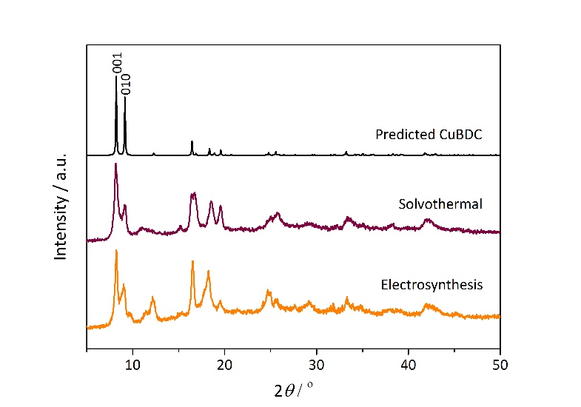
Figure S1. PXRD patterns of the degassed CuBDC.

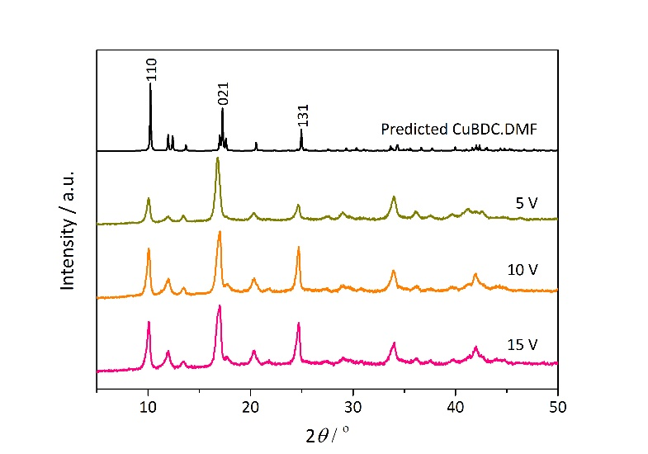
Figure S2. PXRD patterns of the as-synthesized CuBDC at various voltages.

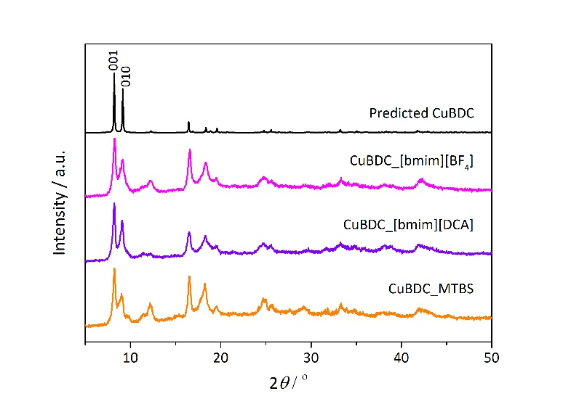
Figure S3. PXRD patterns of the degassed CuBDC at various RTILs.

